
20 Days of Email!

Keep United Way in front of everyone during your campaign and throughout the year! Every day or every week, share with your employees these facts, figures and “did you knows” about United Way of Forsyth County. Show them the impact their dollars are making right here in our community.

Simply copy and paste one fact into an email and keep your co-workers informed at United Way.

1 | Thanks to the generosity of so many individuals, organizations and businesses in our community, in 2020 United Way of Forsyth County supporters pledged $1,240,238 during the annual campaign. Funds raised will help support United Way’s efforts in the areas of Education, Financial Stability, Health and Basic Needs.  GIVE. ADVOCATE. VOLUNTEER. LIVE UNITEDTM
2 | We help children START STRONG, youth GROW STRONG and families STAY STRONG by focusing on the basic foundations for a better life – quality Education, Financial Stability, sufficient Basic Needs and good Health. These are the building blocks that we all need for a good life. Our goal is to create long-lasting changes by addressing the underlying causes of problems. That’s what it means to LIVE UNITED!  GIVE. ADVOCATE. VOLUNTEER. LIVE UNITEDTM
3 | 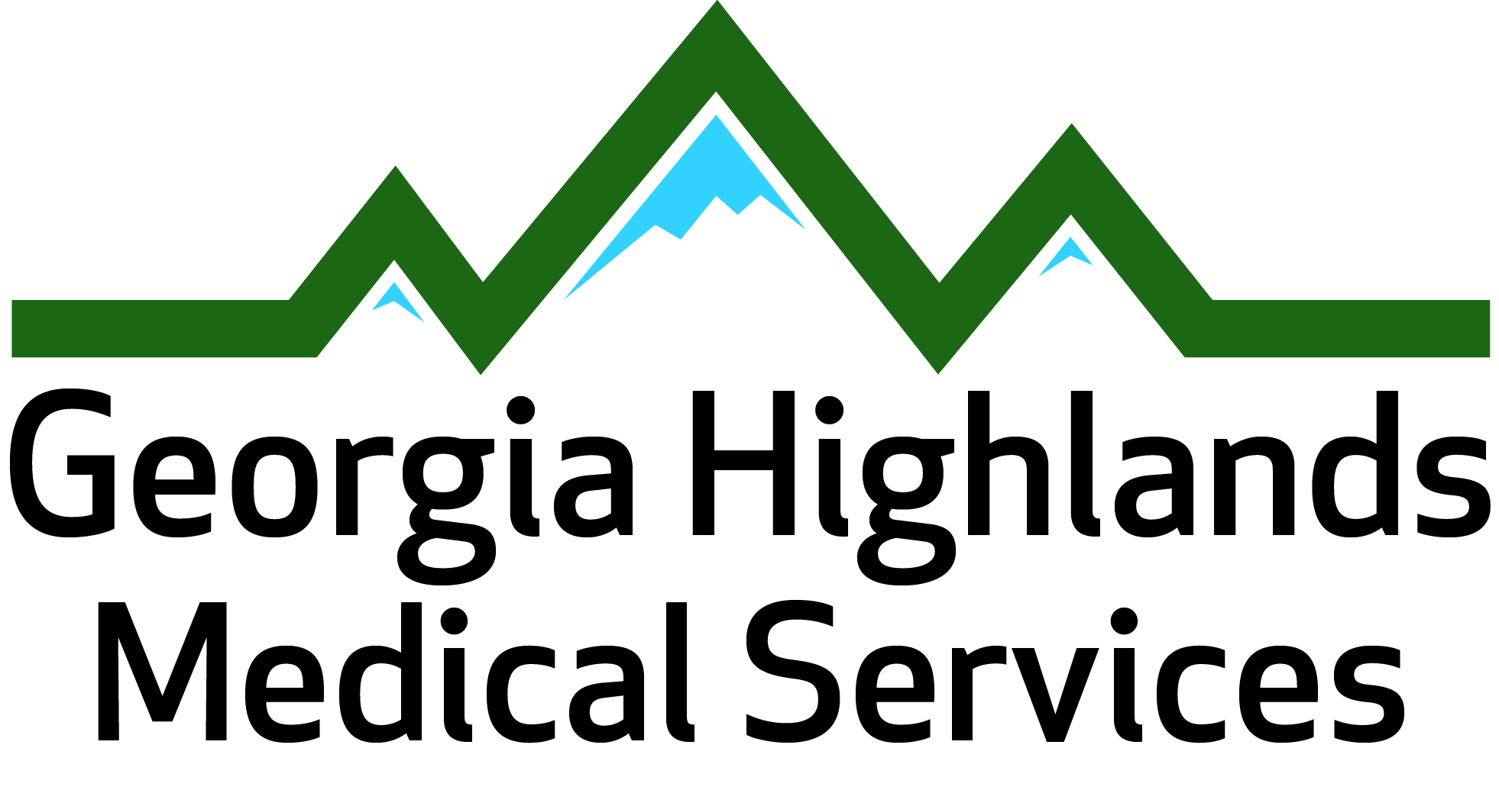  Did you know? In 2020, with the support of United Way of Forsyth County,  Georgia Highlands Medical Services Pharmacy provided 46,731 prescriptions to low-income patients with a Net Cost Savings of $778,840 in out-of-pocket expenses.  GIVE. ADVOCATE. VOLUNTEER. LIVE UNITEDTM
4 | United Way of Forsyth County’s Day of Caring looked very different in 2020, however volunteers were able to sponsor or package 44,643 meals of bean soup, oatmeal and pasta, then distribute to nine different food pantries or local organizations for their clients.  GIVE. ADVOCATE. VOLUNTEER. LIVE UNITEDTM
5 | 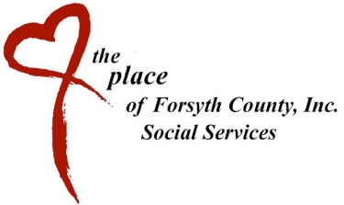  In 2020, The Place of Forsyth County served appx. 165 families per week through The Market, a client choice food pantry that is structured as a shopping experience for the families and is supplemented with fresh fruit, vegetables, eggs and/or meat in addition to bread, pastries and pre-packaged food items. Last year, the garden provided almost 1,700 pounds of fresh vegetables.  GIVE. ADVOCATE. VOLUNTEER. LIVE UNITEDTM
6 | In 2020, United Way of Forsyth County invested $1,159,263 into 47 programs that assisted over 46,000 people in our community. Children and youth succeeded, families and individuals achieved self sufficiency, senior adults were strengthened, and a safety net of essential human care services was maintained.  GIVE. ADVOCATE. VOLUNTEER. LIVE UNITEDTM

20 Days of Email (cont.)

7 | 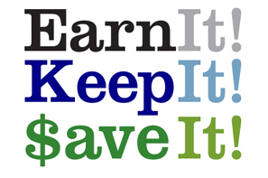  For many low to moderate income families and seniors, the costs associated with having their income taxes prepared can take a bite out of the income they need to support themselves and their families. United Way of Forsyth County and The AARP Tax Aide Program team up each tax season to provide FREE Income Tax preparation to assist low to moderate income families (those earning $54,000 or less) and those individuals 60 years and older in Forsyth, Dawson and surrounding counties. In 2020, before the pandemic, 235 returns were completed at no cost, refunding $311,276 to these clients. Free tax preparation supports the goal of VITA and United Way of Forsyth County to build financial stability for everyone in our community.  GIVE. ADVOCATE. VOLUNTEER. LIVE UNITEDTM
8 | The Georgia Mountain Food Bank, which serves Hall, Dawson, Forsyth, Lumpkin and Union Counties, provided more than 275,000 lbs of food to Forsyth County food pantries to meet the needs of our residents during the pandemic.  GIVE. ADVOCATE. VOLUNTEER. LIVE UNITEDTM
9 | 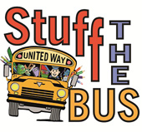  In 2020, with the help of local businesses, civic clubs, individuals and families, United Way’s Stuff the Bus initiative collected school supply items valued at $17,627 that were distributed to students in need through Forsyth County Schools, The Place and other nonprofits in the community during the 2020-2021 school year.  GIVE. ADVOCATE. VOLUNTEER. LIVE UNITEDTM
10 | 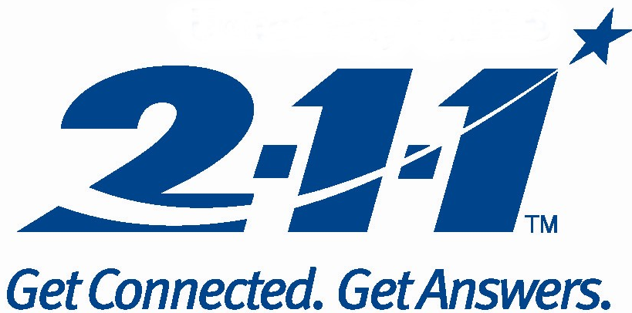  Need help or want to give help? It’s as simple as dialing 2-1-1. United Way 2-1-1 is a free, confidential information and referral service that connects people to trained call specialists who help them find local resources for everyday needs or in times of crisis or disaster. The majority of calls request information about utility assistance, housing assistance and food.  GIVE. ADVOCATE. VOLUNTEER. LIVE UNITEDTM
11 | 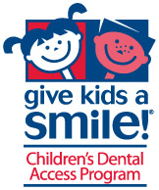  Through a collaborative between Forsyth County Schools, local dental practices and United Way, over 57 smiles were brightened through Give Kids A Smile Day in February of 2020. Students from 16 different schools that otherwise would not receive dental services were given screenings, x-rays and cleanings, free of charge from 3 participating dentists.  GIVE. ADVOCATE. VOLUNTEER. LIVE UNITEDTM
12 | Together, you and United Way of Forsyth County invest dollars for impact on lives in our community. Through a process trained community volunteers – people just like you - decide where the money will have the most impact. All requests from agencies and programs must demonstrate conclusively that their programs are meeting the needs of our community in order to be considered for funding.  GIVE. ADVOCATE. VOLUNTEER. LIVE UNITEDTM

20 Days of Email (cont.)

13 | 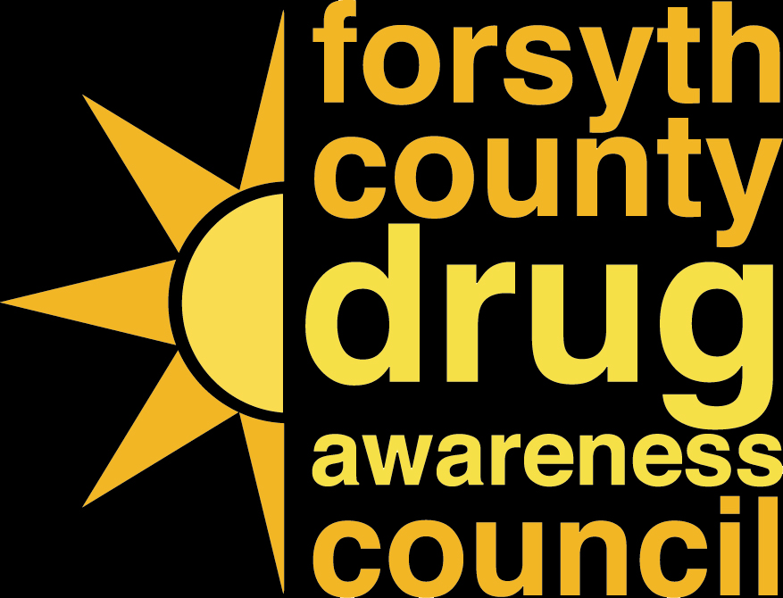  The Forsyth County Drug Awareness Council was started in 2013 to educate, advocate and empower youth, parents and all other citizens to prevent substance use and abuse throughout Forsyth County. United Way of Forsyth County serves as the administrator for a federal grant the Council received, provides administrative support to the program and in 2020 impacted over 700 lives in our community.  GIVE. ADVOCATE. VOLUNTEER. LIVE UNITEDTM
14 | United Way realizes to create positive, lasting community change we need to get to the root cause of our most critical needs. It’s not enough to find a shelter for a family; but to change the condition that led to homelessness in the first place. This requires the work of our entire community. All this is done in collaboration with diverse community partners: individuals, businesses, partner agencies, schools, government, civic clubs, faith-based organizations and many others. United Way of Forsyth County knows where your contribution is most needed to have the greatest impact. United Way is your best investment because we’re effective, efficient and convenient.  GIVE. ADVOCATE. VOLUNTEER. LIVE UNITEDTM

15 | In 2020, 41 United Way student scholarships, valued at over $15,000 were awarded at Lanier Technical College. These scholarships help bridge the financial gap between costs that were not covered by the Hope Scholarship which excluded anyone from eligibility who graduated from high school more than seven years ago. These scholarships allowed students to complete their degrees, giving them the skills to be highly competitive in today’s job market and lead more self-sufficient lives.  GIVE. ADVOCATE. VOLUNTEER. LIVE UNITEDTM
16 | United Way of Forsyth County funds Forsyth County Schools’ Credit Recovery program, which offsets expenses associated with Credit Recovery and initial credit opportunities such as course tuition, computer equipment and high speed internet connections was one program helping increase the graduation rate from 85.8% in 2008 to 96.4% in 2019  GIVE. ADVOCATE. VOLUNTEER. LIVE UNITEDTM
17 | 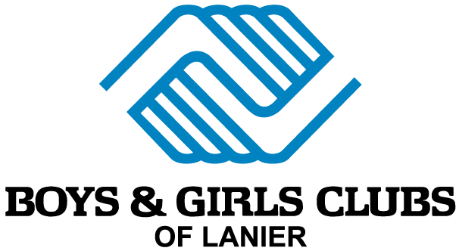  In 2020, the Boys & Girls Club in Forsyth County served 189 students at Cumming Elementary with tutoring and enrichment activities. It is estimated that 25%-35% of people in the area of Cumming Elementary School live in poverty. By offering an afterschool program through Boys & Girls Clubs, parents with one child in the program will be receiving a savings of approximately 58% of their current afterschool costs, making available more money for food, rent and other necessities.  GIVE. ADVOCATE. VOLUNTEER. LIVE UNITEDTM

20 Days of Email (cont.)

18 | Because United Way recognizes the importance of education, over $1.337 million has been invested directly into Forsyth County School System programs over the past 14 years. Programs that provided scholarships for special needs students for summer camp, transportation for high school clubs to do service projects, support programs for students with special needs and many other means of support that are helping to build a strong educational foundation for the children and youth in our community.  GIVE. ADVOCATE. VOLUNTEER. LIVE UNITEDTM
19 | Want to know what your contributions are doing in our community? Stay connected with United Way through www.UnitedWayForsyth.com, on Facebook, Twitter and Instagram to see the impact we’re making throughout Forsyth County.   www.facebook.com/UnitedWayForsythCountyGA  @UnitedWayFCGA   @UnitedWayForsythCounty  GIVE. ADVOCATE. VOLUNTEER. LIVE UNITEDTM
20 | One of the most important resources we have is our partners. United Way is engaging people from business, government, nonprofits and ordinary citizens. A long-term commitment is essential when tackling the issues that matter most. Working together, we can get results that no one can accomplish alone. Whether it’s through a grant to a nonprofit for direct services, a collaborative effort on a community-wide initiative or a corporate sponsorship of United Way’s work, each partnership and project addresses one of our target areas: EDUCATION: ensuring children and youth have a foundation to reach their full potential, FINANCIAL STABILITY: ensuring individuals and families are financially secure and self-reliant, HEALTH: ensuring individuals are physically, socially and emotionally healthy and BASIC NEEDS: ensuring people are able to meet their basic needs for food, clothing, shelter and safety.  GIVE. ADVOCATE. VOLUNTEER. LIVE UNITEDTM

